Polygon:

Polygon is a representation of the surface. It is primitive which is closed in nature. It is formed using a collection of lines. It is also called as many-sided figure. The lines combined to form polygon are called sides or edges. The lines are obtained by combining two vertices.

Example of Polygon:

1. Triangle
2. Rectangle
3. Hexagon
4. Pentagon

Following figures shows some polygons.

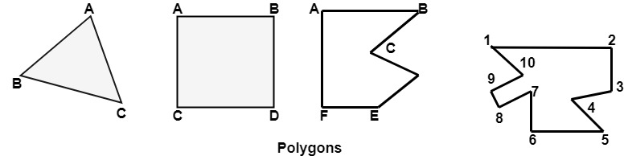

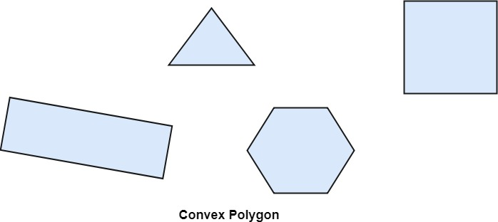

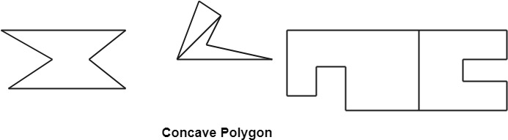

Types of Polygons

1. Concave
2. Convex

A polygon is called convex of line joining any two interior points of the polygon lies inside the polygon. A non-convex polygon is said to be concave. A concave polygon has one interior angle greater than 180°. So that it can be clipped into similar polygons.

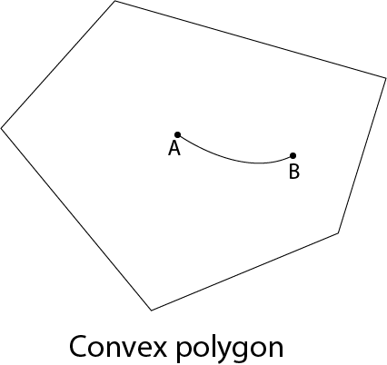

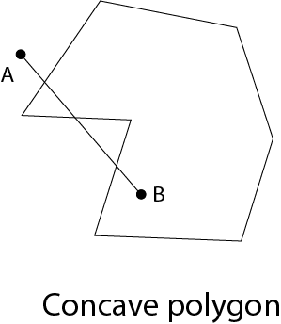

A polygon can be positive or negative oriented. If we visit vertices and vertices visit produces counterclockwise circuit, then orientation is said to be positive.

